AUTOSAR TIMING AND PERFORMANCE TESTING WITH PYTON

SCENARIO:
An AUTOSAR ECU controlling brakes require time and performance validation to ensure real time problem are addressed

OBJECTIVES:
1. Understand time and problem in autosar
2. Major task execution time
3. Automate performance analysis using python

TASKS:
1. Identify critical autosar tasks and executables
2. Define time and test cases
3. Simulate load and major receiver response
4. Analyse performance deviations

PYTHON HANDS-ON:
1. Use python to capture timestamps from ECU logs
2. Calculate execution time
3. Generate performance graphs and reports using specific libraries of python

DELIVERABLES:
1. Time and Test strategy
2. Python performance analysis script
3. Final evolution report

LEARNING OBJECTIVES:
Student understands real time automotive testing and performance validation using python and autosar

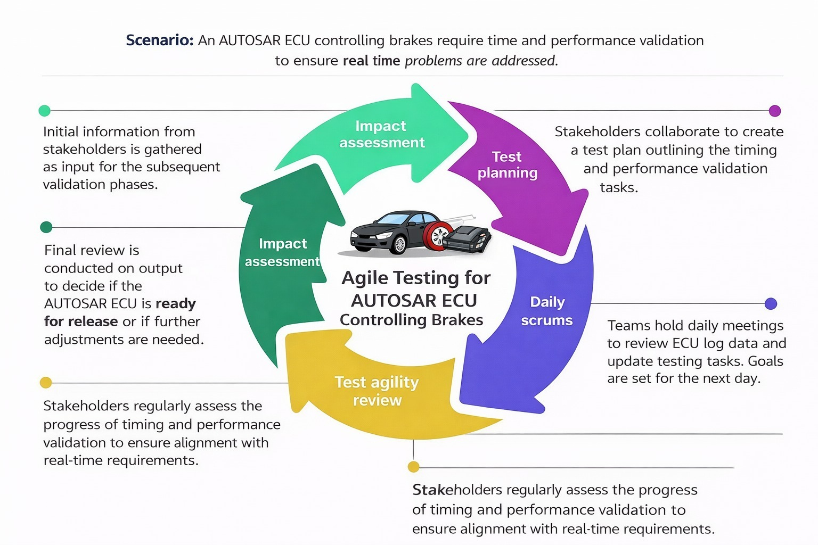

1. Impact Assessment
- Gather stakeholder inputs to identify real-time timing and performance risks in the brake ECU.
- Analyze the impact of timing issues on safety-critical braking functions.

2. Test Planning
- Define timing, performance, and real-time validation test cases for AUTOSAR tasks.
- Prepare test strategy, tools, schedules, and expected outcomes collaboratively.

3. Daily Scrums
- Review ECU logs, execution timings, and Python-based test results daily.
- Update priorities, resolve blockers, and plan testing activities for the next day.

4. Test Agility Review
- Evaluate performance results against real-time requirements and deadlines.
- Identify deviations and adapt test cases or load scenarios accordingly.

5. Release Readiness
- Perform final validation to confirm ECU meets timing and performance criteria.
- Decide whether the ECU is ready for release or requires further optimization.

Android Testing in Cars
Introduction:
Nowadays, automobiles are becoming smarter with the integration of advanced software systems. One of the most widely used technologies in modern cars is Android-based infotainment systems. These systems allow drivers and passengers to access navigation, music, calls, messages, and voice assistants directly from the car’s dashboard. Examples include Android Auto and Android Automotive OS.
Since these systems interact directly with drivers, testing them is very important to ensure safety, smooth performance, and reliability. Android testing in cars focuses on validating that applications and system functions work correctly in real driving environments.
Objective of Android Testing in Cars:
The main objectives of testing Android systems in cars are:
- To verify that infotainment applications work correctly.
- To ensure stable connection between smartphone and car system.
- To check system performance under different driving conditions.
- To ensure driver safety by minimizing distractions.
- To confirm that software updates do not introduce new issues.
Example System
Example: Android-based Infotainment System in a Smart Vehicle.
Features of the System:
- Touchscreen media player
- GPS navigation
- Bluetooth calling
- Voice assistant (Google Assistant)
- Climate control display
- Vehicle status monitoring
This system allows users to control entertainment and navigation without using their mobile phones while driving.

Need for Android Testing in Cars
- The system must work continuously without crashes.
- Any failure may distract the driver.
- Connectivity with mobile phones must be smooth.
- The UI should be simple and easy to use.
- Performance should remain stable during long drives.
Types of Testing Performed
1. Functional Testing
Functional testing verifies that every feature of the system works according to the specified requirements.
Music Playback
- Verify play, pause, stop, next, and previous functions.
- Test different audio formats and streaming services.
- Check volume control, equalizer settings, and audio output switching (speakers, Bluetooth).
GPS Route Calculation
- Validate accurate route generation and turn-by-turn navigation.
- Test rerouting when the driver misses a turn.
- Confirm real-time traffic updates and ETA recalculations.
Making and Receiving Calls
- Test incoming, outgoing, and missed call handling.
- Verify call quality, microphone clarity, and speaker output.
- Check call history access and contact synchronization.
Voice Command Recognition
- Test accuracy with different accents and speech speeds.
- Verify commands for navigation, calls, music, and system settings.
- Ensure correct error handling for unrecognized commands.

2. Connectivity Testing
Ensures proper communication between devices.
Bluetooth Pairing with Smartphones
- Verify pairing, unpairing, and reconnection behavior.
- Test contact sharing, call audio, and media streaming.
- Check stability during long drives.
Android Auto Connection Setup
- Validate wired and wireless connection flows.
- Test automatic reconnection after ignition restart.
- Ensure app synchronization and permissions handling.
3. User Interface (UI) Testing
UI testing focuses on usability, visual consistency, and user interaction.
Touchscreen Responsiveness
- Test touch accuracy, swipe gestures, and multi-touch support.
- Verify responsiveness while the vehicle is in motion.
Proper Icon Display
- Ensure icons are correctly aligned and scaled.
- Validate consistent design across all screens.
- Test localization for different languages and regions.
Day and Night Mode Switching
- Verify automatic switching based on time or ambient light.
- Check readability and contrast in both modes.
4. Performance Testing
Performance testing evaluates the system’s speed, stability, and behavior under load.
Response Delay During Multitasking
- Verify system responsiveness while running multiple apps.
- Test switching between navigation, calls, and media playback.
- Check for lag or freezes.
System Behavior During High Load
- Simulate heavy usage (GPS + music + calls).
- Monitor CPU, memory usage, and system temperature.
- Ensure no crashes or unexpected reboots.
5. Compatibility Testing
Compatibility testing ensures the system works across different devices and configurations.
Connecting Different Android Phone Versions
- Test with multiple Android OS versions.
- Verify backward and forward compatibility.
- Ensure consistent behavior across updates.
Testing Various Screen Sizes and Resolutions
- Validate UI scaling on different display sizes.
- Ensure text and icons remain readable.
- Check layout consistency in portrait and landscape modes.
6. Safety Testing
Safety testing ensures the system complies with automotive safety standards and minimizes driver distraction.
Voice Commands Instead of Manual Typing
- Verify that voice input is enabled for critical functions.
- Ensure typing is restricted while the vehicle is moving.
Automatic Disabling of Video Playback While Driving
- Confirm video apps are disabled once the vehicle is in motion.
- Test re-enabling when the vehicle is parked.
- Validate compliance with legal and regulatory requirements.

Challenges in Android Car Testing
- Hardware Availability - Limited access to real car hardware.
- Real-world Driving Scenarios - Testing under real driving conditions.
- Device Fragmentation - Hardware variations between car models.
- Network Stability - Network fluctuations.
- Safety Compliance - Ensuring safety compliance standards.
Future Scope:
In the future, Android car systems will integrate AI-based assistants, gesture controls, and autonomous driving features. Testing will become more advanced with simulation-based validation and real-time monitoring tools.
Conclusion:
Android testing in cars plays a crucial role in delivering safe, reliable, and user-friendly automotive systems. Through functional, performance, and safety testing, developers ensure that infotainment systems operate smoothly in real-world driving conditions. As smart vehicles evolve, effective Android testing will remain essential for improving driver experience and road safety.

